EX:03 TURF MANAGEMENT SYSTEM USING ZIA IN ZOHO CREATOR
Observation:
Introduction:
The Turf Management System is a digital application developed to efficiently monitor and manage the health and maintenance activities of a turf area. The system provides a centralized platform for recording mowing schedules, irrigation monitoring, fertilization activities, turf area details, and turf health assessments. It helps turf managers maintain healthy playing surfaces by organizing important maintenance information in a structured manner.
Objective:
The objective of the Turf Management System is to develop an organized application for monitoring turf maintenance activities and turf health. The system aims to simplify mowing, irrigation, fertilization, turf area management, and health assessment activities while providing a dashboard for monitoring the overall condition of the turf.
Dashboard:
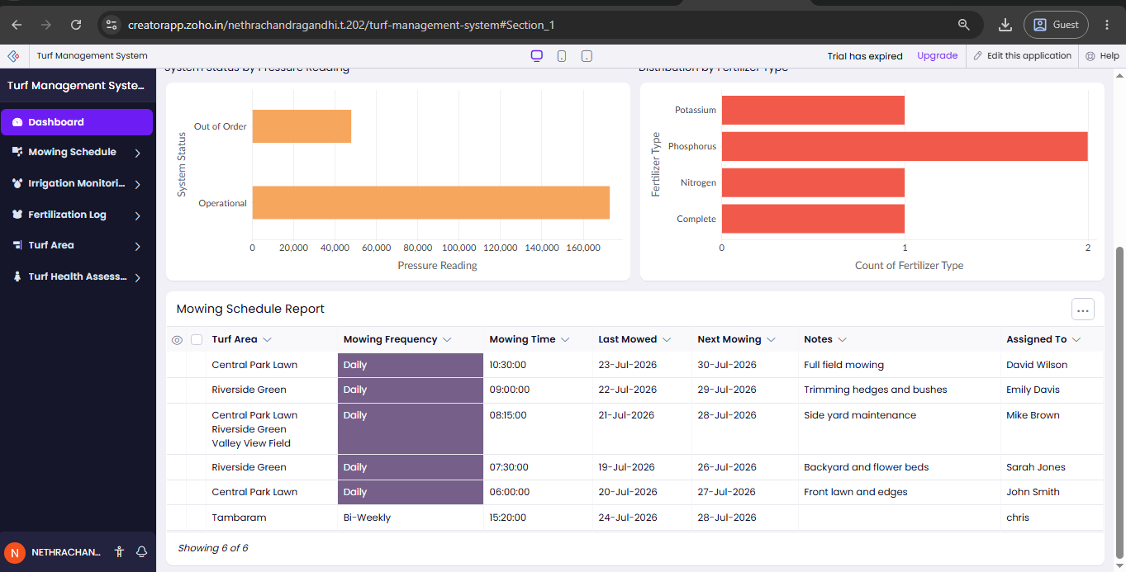The Dashboard provides an overview of important turf management information in a centralized interface. It allows the user to access different modules such as Mowing Schedule, Irrigation Monitoring, Fertilization Log, Turf Area, and Turf Health Assessment. The dashboard helps the turf manager quickly navigate through the application and monitor the overall status of turf maintenance activities.
Mowing Schedule: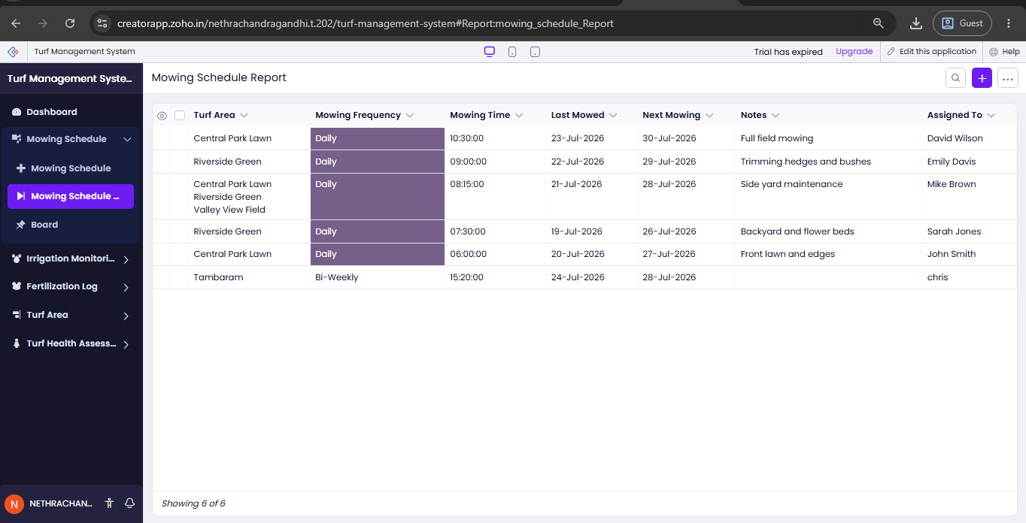The Mowing Schedule module is used to plan and record turf mowing activities. It can maintain details such as mowing date, scheduled time, turf area, mowing frequency, assigned personnel, and completion status. Proper scheduling helps maintain uniform turf height and prevents irregular mowing practices.
Irrigation Monitoring: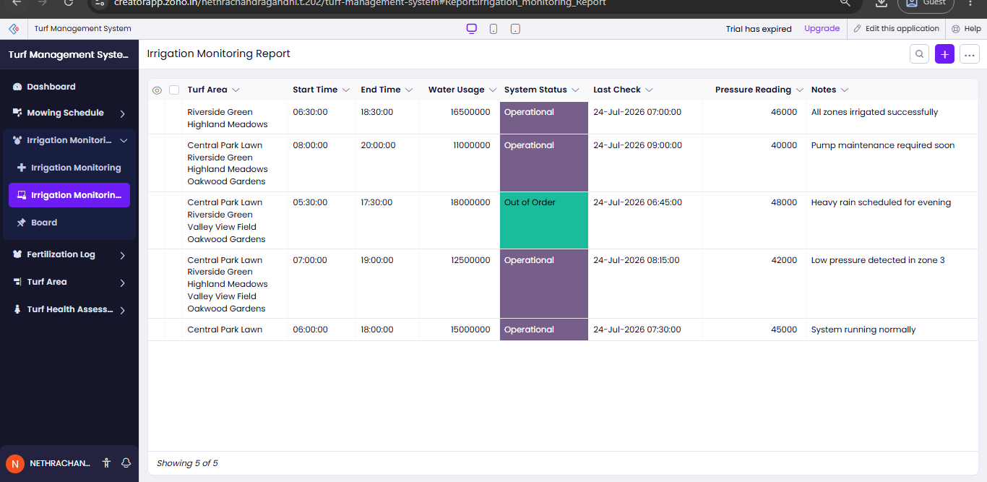The Irrigation Monitoring module is used to record and monitor watering activities for different turf areas. It can include information such as irrigation date, turf area, watering duration, water quantity, irrigation status, and remarks. Monitoring irrigation helps ensure that the turf receives an appropriate amount of water and reduces unnecessary water usage.
Fertilization Log: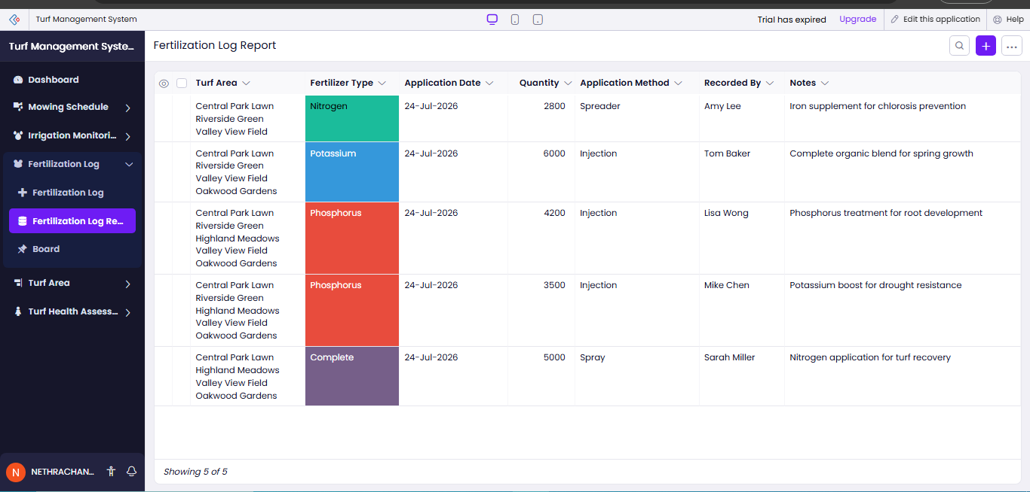
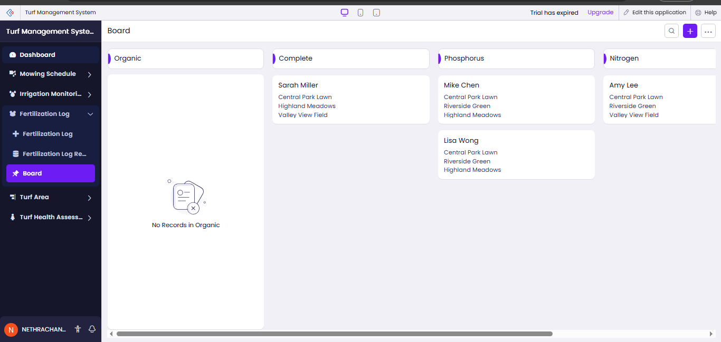
The Fertilization Log module maintains records of fertilizer application activities. It can store information such as application date, turf area, fertilizer type, quantity applied, application method, and remarks. Maintaining a proper fertilization record helps ensure that nutrients are supplied to the turf according to its requirements.
Turf Area: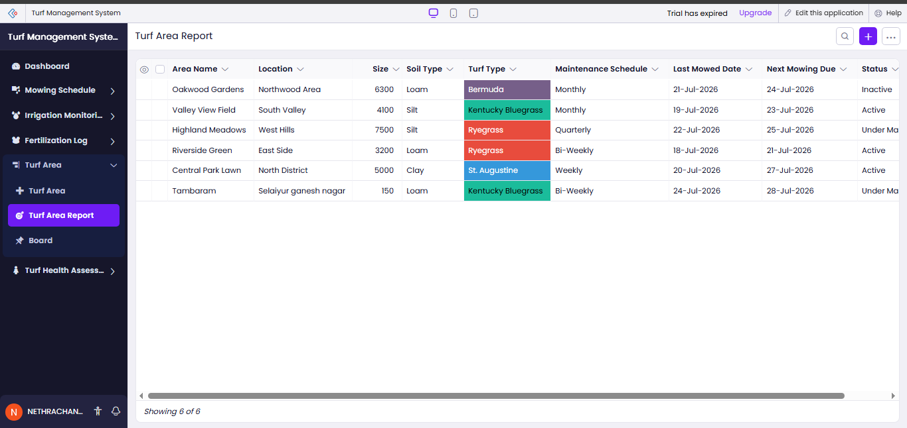
The Turf Area module is used to maintain information about individual turf areas. It can contain details such as area name, location, size, turf type, current condition, and maintenance requirements. This module helps the manager monitor different turf areas independently and organize their maintenance activities.
Turf Health Assessment:
The Turf Health Assessment module is used to evaluate the overall condition of the turf. It can record parameters such as turf quality, grass density, color, moisture condition, pest or disease presence, and general health status. Regular assessment helps identify problems at an early stage and supports timely maintenance decisions.
Turf Health Assessment Records:
The Turf Health Assessment records provide detailed information about individual turf health inspections. Each assessment can be associated with a particular turf area and can include observations, assessment date, health condition, issues identified, and recommended actions. These records help track changes in turf health over time.
Board:
The Board module provides a visual area for displaying important turf management information and updates. It can be used to monitor observations, turf conditions, or important activities requiring attention. The board supports quick access to relevant information and helps the manager prioritize maintenance tasks.
Maintenance Monitoring:
The system allows different turf maintenance activities to be monitored from a single application. Mowing, irrigation, fertilization, and health assessments can be recorded systematically. This reduces dependency on manual records and makes it easier to track the maintenance history of each turf area.
Data Management:
The Turf Management System stores maintenance and assessment information in an organized manner. The collected data can be used to review previous activities, identify recurring turf problems, compare turf conditions, and plan future maintenance activities.
Observation:
The Turf Management System provides an organized solution for managing turf maintenance and health monitoring activities. The modules shown in the application, including Dashboard, Mowing Schedule, Irrigation Monitoring, Fertilization Log, Turf Area, Turf Health Assessment, and Board, provide a structured method for recording and monitoring turf-related information. The system reduces manual record keeping and helps the turf manager make informed maintenance decisions based on recorded data.
Result:
The Turf Management System was successfully developed to manage turf maintenance and health assessment activities through a centralized application. The system enables users to maintain mowing schedules, monitor irrigation, record fertilization activities, manage turf areas, and assess turf health. The dashboard and board provide convenient access to important information, resulting in improved organization, monitoring, and management of turf maintenance operations.
Conclusion:
The Turf Management System provides an efficient digital solution for maintaining healthy and well-managed turf areas. By integrating mowing, irrigation, fertilization, turf area management, and turf health assessment into a single application, the system improves maintenance tracking and reduces manual effort. The application can be further enhanced with automated reminders, health trend analysis, weather-based irrigation recommendations, and AI-based turf health predictions.

